Sample paper- 2
Class XIth
Biology
Time: 3 hrs MM: 70
General instructions:
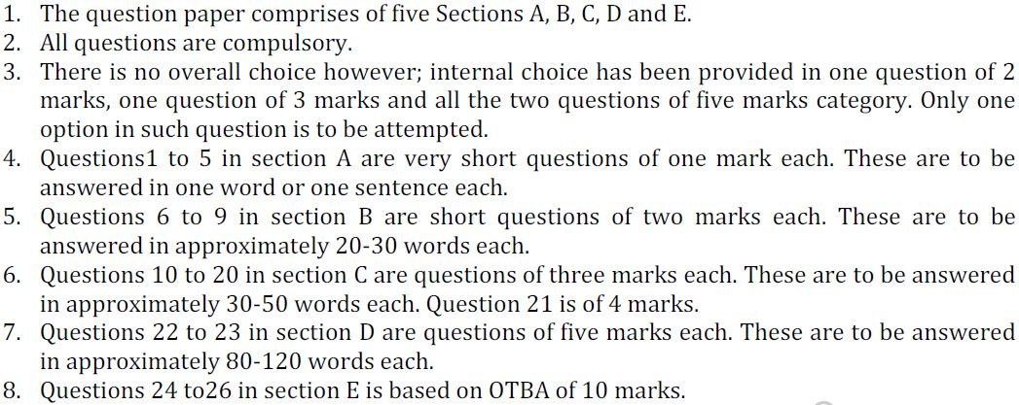

Section A
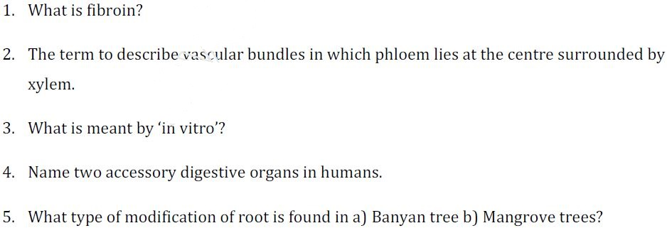

Section B
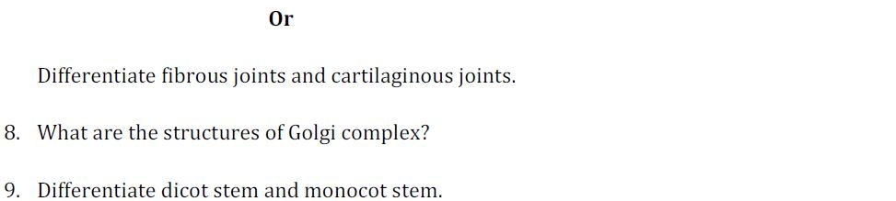

Section C
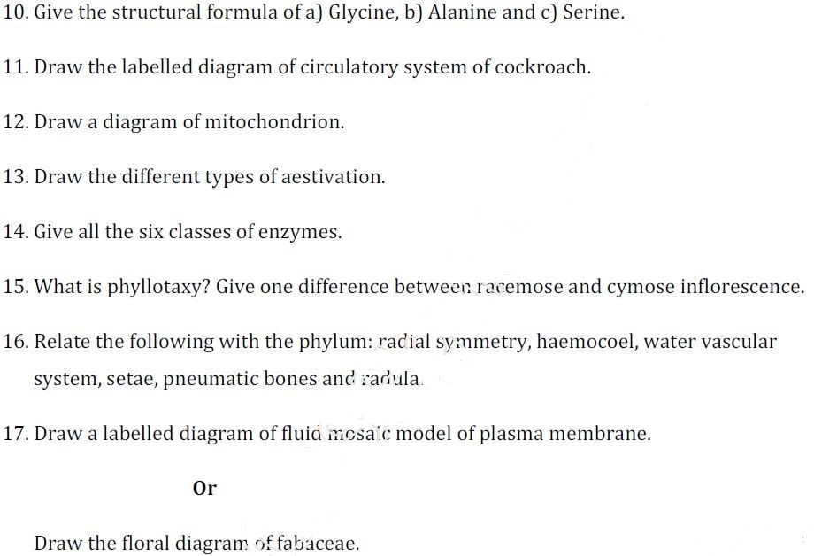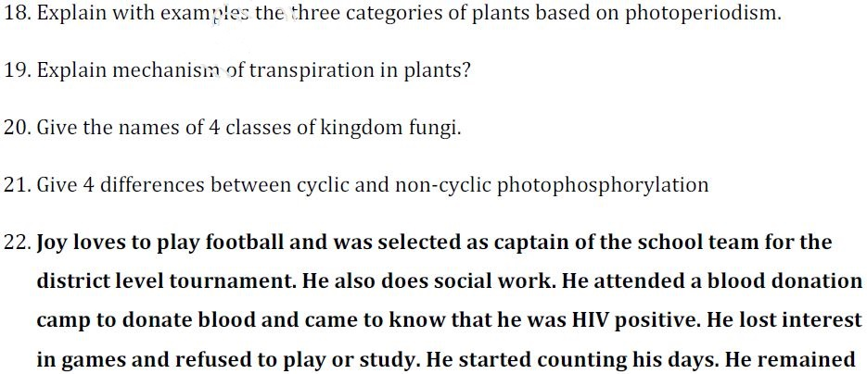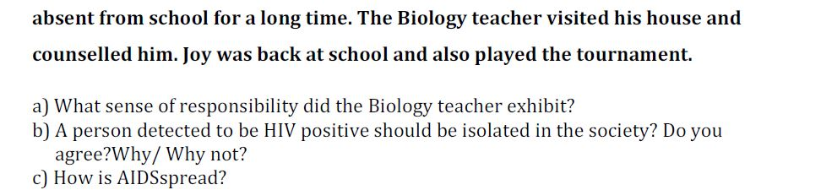

Section D
23. Explain the prophase I in meiosis with the help of diagram.

Or

Draw the diagram of Ts of cilia & explain its structure.

24. Explain C4 cycle in plants. How it is more efficient than C3 cycle.

Or

Explain Krebs cycle for aerobic respiration.
Section E

